ITEC 570 SPRING 2024

Group Activity #2

Ahmed Altouqi
Aaltouqi
ITEC 570
GP 2

For each document submitted on-line, please include your name, username, date, ITEC 570-001, reference lab number and title(if appropriate).

Whenever possible, upload PDF files versus word or pages.

Concepts. Use Chapter 4 of your book for help.

- The Jonesburgh County Basketball Conference (JCBC) is an amateur basketball association. Each city in the county has one team as its representative. Each team has a maximum of 12 players and a minimum of 9 players. Each team also has up to 3 coaches (offensive, defensive, and physical training coaches). During the season, each team plays 2 games (home and visitor) against each of the other teams. Given those conditions, do the following:

- Identify the connectivity of each relationship.
  - City-Team Relationship:
    - One-to-One
  - Team-Player Relationship:
    - One-to-Many
  - Team-Coach Relationship:
    - One-to-Many
  - Team-Game Relationship:
    - Many-to-Many

- Identify the type of dependency that exists between CITY and TEAM.
  - Functional Dependency

- Identify the cardinality between teams and players and between teams and city.
  - Teams and Players 1:N
  - Teams and City 1:1

- Identify the dependency between COACH and TEAM and between TEAM and PLAYER.
  - Coach and Team: Associative
  - Team and Player: Functional

- Draw the Chen and Crow’s Foot ERDs to represent the JCBC database.

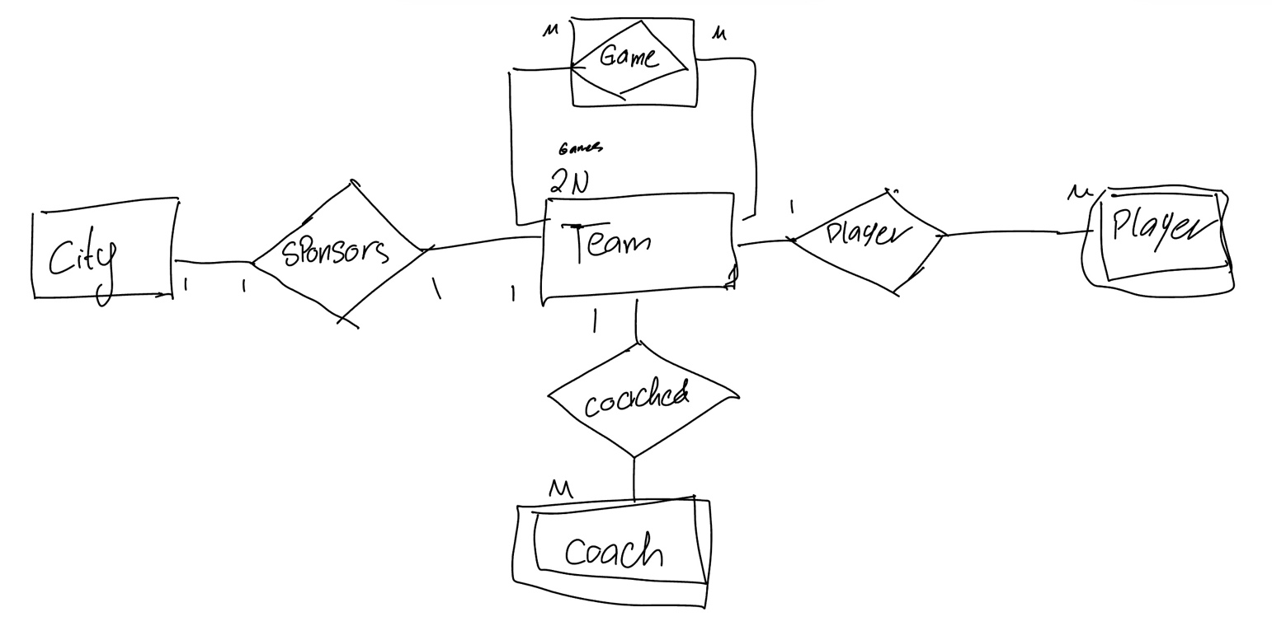

- United Helpers is a nonprofit organization that provides aid to people after natural disasters. Based on the following brief description of operations, create the appropriate fully labeled Crow’s Foot ERD.

- Volunteers carry out the tasks of the organization. The name, address, and telephone number are tracked for each volunteer. Each volunteer may be assigned to several tasks, and some tasks require many volunteers. A volunteer might be in the system without having been assigned a task yet. It is possible to have tasks that no one has been assigned. When a volunteer is assigned to a task, the system should track the start time and end time of that assignment.

- Each task has a task code, task description, task type, and task status. For example, there may be a task with task code “101,” a description of “answer the telephone,” a type of “recurring,” and a status of “ongoing.” Another task might have a code of “102,” a description of “prepare 5,000 packages of basic medical supplies,” a type of “packing,” and a status of “open.”

- For all tasks of type “packing,” there is a packing list that specifies the contents of the packages. There are many packing lists to produce different packages, such as basic medical packages, child-care packages, and food packages. Each packing list has an ID number, a packing list name, and a packing list description, which describes the items that should make up the package. Every packing task is associated with only one packing list. A packing list may not be associated with any tasks, or it may be associated with many tasks. Tasks that are not packing tasks are not associated with any packing list.

- Packing tasks result in the creation of packages. Each individual package of supplies produced by the organization is tracked, and each package is assigned an ID number. The date the package was created and its total weight are recorded. A given package is associated with only one task. Some tasks (such as “answer the phones”) will not produce any packages, while other tasks (such as “prepare 5,000 packages of basic medical supplies”) will be associated with many packages.

- The packing list describes the ideal contents of each package, but it is not always possible to include the ideal number of each item. Therefore, the actual items included in each package should be tracked. A package can contain many different items, and a given item can be used in many different packages.

- Each item that the organization provides has an item ID number, item description, item value, and item quantity on hand stored in the system. Along with tracking the actual items that are placed in each package, the quantity of each item placed in the package must be tracked as well. For example, a packing list may state that basic medical packages should include 100 bandages, 4 bottles of iodine, and 4 bottles of hydrogen peroxide. However, because of the limited supply of items, a given package may include only 10 bandages, 1 bottle of iodine, and no hydrogen peroxide. The fact that the package includes bandages and iodine needs to be recorded along with the quantity of each item included. It is possible for the organization to have items that have not been included in any package yet, but every package will contain at least one item.

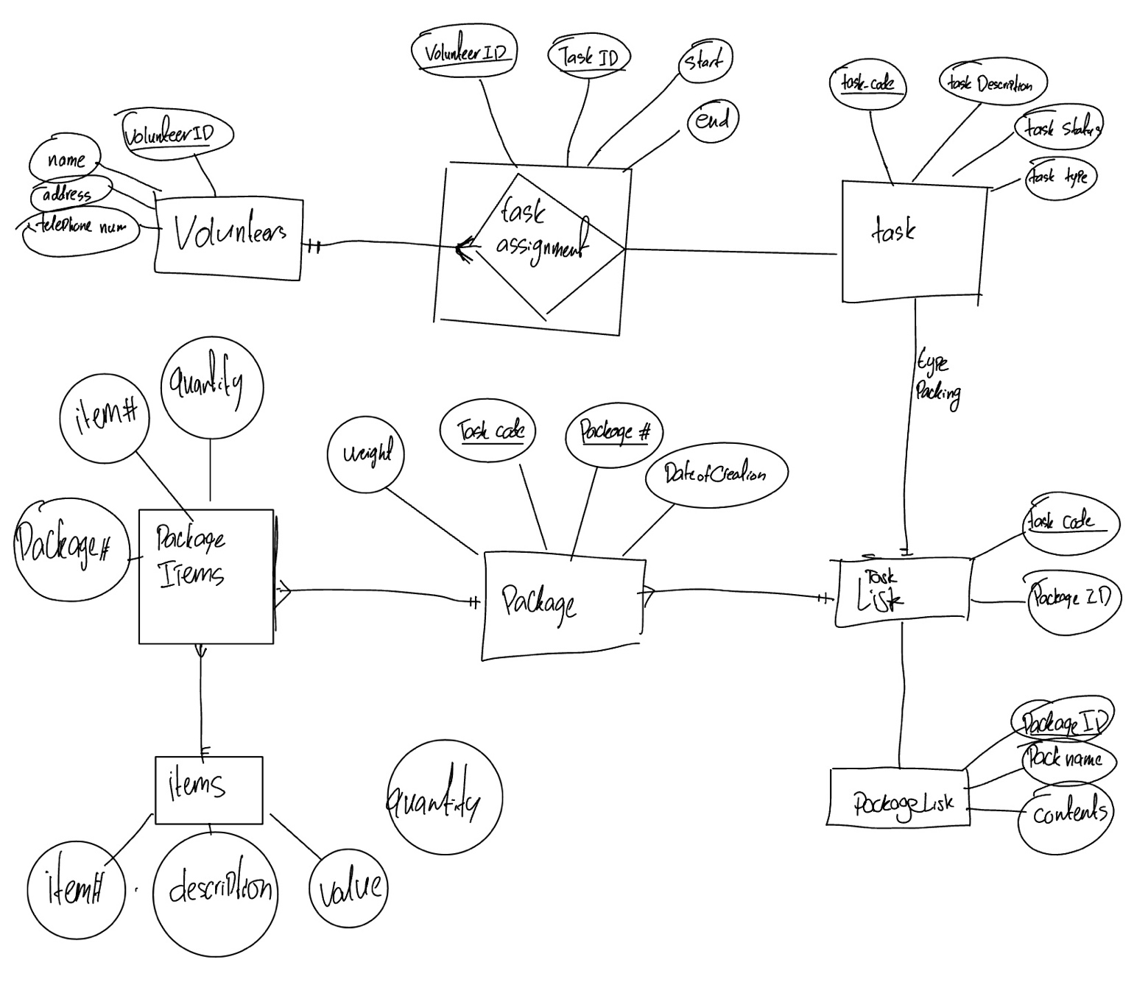

Concepts. Use Chapter 5 of your book for help.

- Given the following business scenario, create a Crow’s Foot ERD using a specialization hierarchy if appropriate.
- Tiny Hospital keeps information on patients and hospital rooms.
- The system assigns each patient a patient ID number.
- In addition, the patient’s name and date of birth are recorded.
- Some patients are resident patients who spend at least one night in the hospital, and others are outpatients who are treated and released.
- Resident patients are assigned to a room.
- Each room is identified by a room number.
- The system also stores the rovb com type (private or semiprivate) and room fee.
- Over time, each room will have many patients.
- Each resident patient will stay in only one room.
- Every room must have had a patient, and every resident patient must have a room.

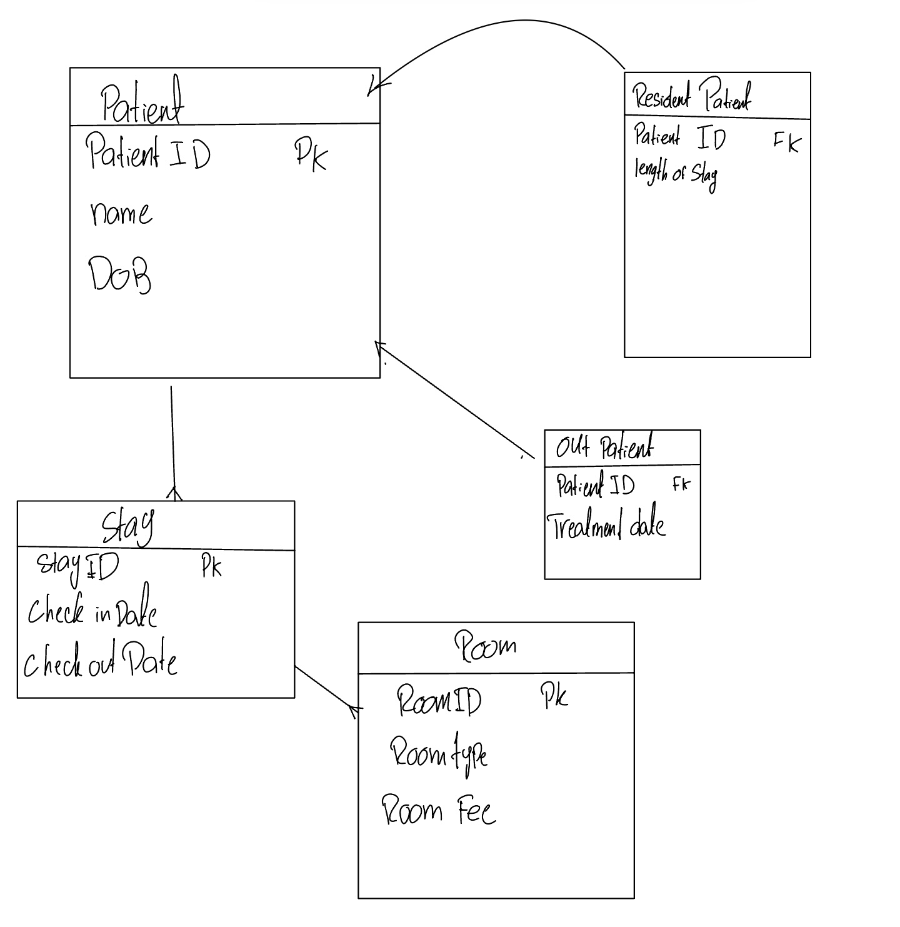

- “Martial Arts R Us” (MARU) needs a database. MARU is a martial arts school with hundreds of students. The database must keep track of all the classes that are offered, who is assigned to teach each class, and which students attend each class. Also, it is important to track the progress of each student as they advance. Create a complete Crow’s Foot ERD for these requirements:

- Students are given a student number when they join the school. The number is stored along with their name, date of birth, and the date they joined the school.

- All instructors are also students, but clearly not all students are instructors. In addition to the normal student information, for all instructors, the date that they start working as an instructor must be recorded along with their instructor status (compensated or volunteer).

- An instructor may be assigned to teach any number of classes, but each class has one and only one assigned instructor. Some instructors, especially volunteer instructors, may not be assigned to any class.

- A class is offered for a specific level at a specific time, day of the week, and location. For example, one class taught on Mondays at 5:00 p.m. in Room 1 is an intermediate-level class. Another class taught on Mondays at 6:00 p.m. in Room 1 is a beginner-level class. A third class taught on Tuesdays at 5:00 p.m. in Room 2 is an advanced-level class.

- Students may attend any class of the appropriate level during each week, so there is no expectation that any particular student will attend any particular class session. Therefore, the attendance of students at each individual class meeting must be tracked.

- A student will attend many different class meetings, and each class meeting is normally attended by many students. Some class meetings may not be attended by any students. New students may not have attended any class meetings yet.

- At any given meeting of a class, instructors other than the assigned instructor may show up to help. Therefore, a given class meeting may have a head instructor and many assistant instructors, but it will always have at least the one instructor who is assigned to that class. For each class meeting, the date of the class and the instructors’ roles (head instructor or assistant instructor) need to be recorded. For example, Mr. Jones is assigned to teach the Monday, 5:00 p.m., intermediate class in Room 1. During a particular meeting of that class, Mr. Jones was the head instructor and Ms. Chen served as an assistant instructor.

- Each student holds a rank in the martial arts. The rank name, belt color, and rank requirements are stored. Most ranks have numerous rank requirements, but each requirement is associated with only one particular rank. All ranks except white belt have at least one requirement.

- A given rank may be held by many students. While it is customary to think of a student as having a single rank, it is necessary to track each student’s progress through the ranks. Therefore, every rank that a student attains is kept in the system. New students joining the school are automatically given the rank of white belt. The date that a student is awarded each rank should be kept in the system. All ranks have at least one student who has achieved that rank at some time.



